Group 1: Mia (Mingyi Huang), Hao Gao, Wei Zhang, Yiming Wei, Huadong Shen

We want to utilize electrophysiology and/or optical imaging data and/or EEG/MEG data, combined with biophysical models and/or machine learnings to understand how interneuron/ inhibition shapes cortical activity.

Specifically, we want to investigate how inhibition contributes to decision making in mice or primates or humans

Group 2: 江晨阳，熊关越，曹亦淳，吴向舒，龚政鑫

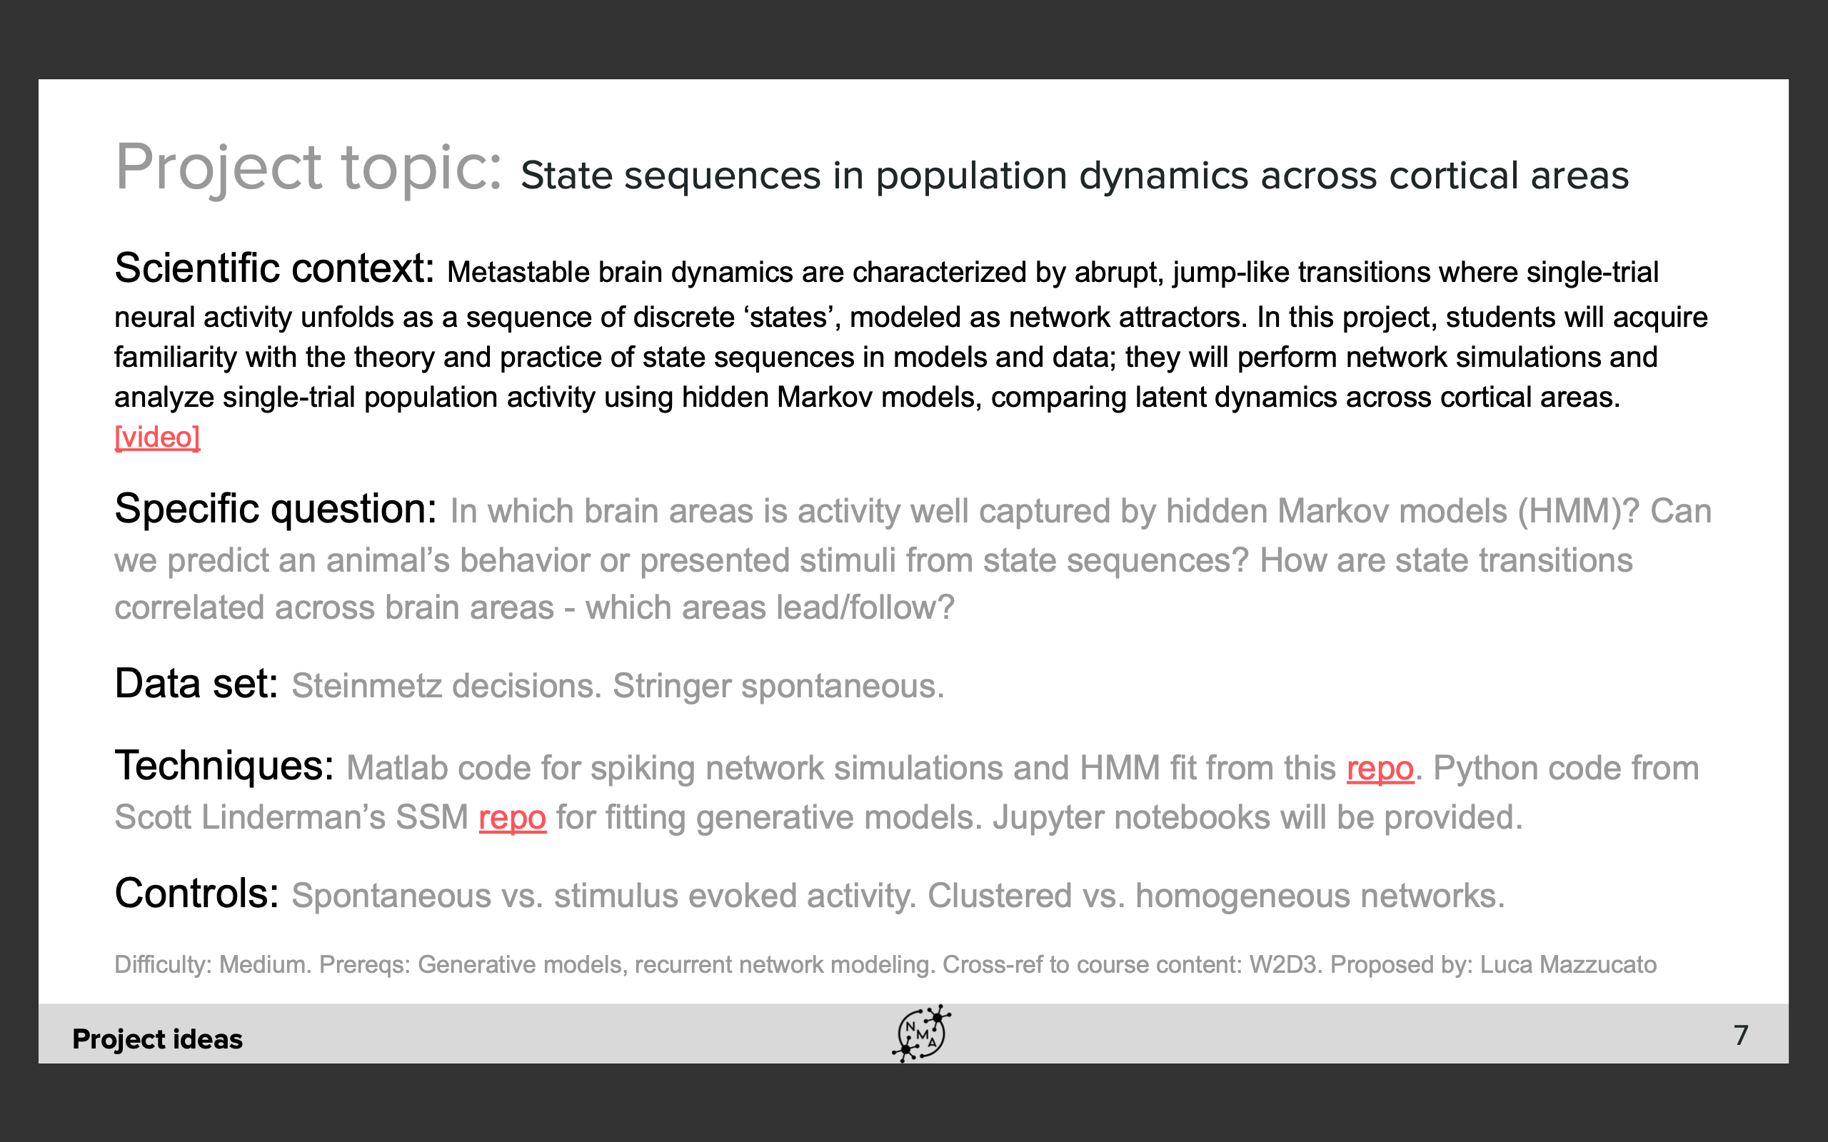

Group 3: 李安琪，陈佳涵，赵宇

